1. Explore Settings Tab
Explore and understand all the options currently available in the Settings tab, including:
Multiple browser support, Headless execution, Retry mechanism, Any other available configuration options
Multiple browser support
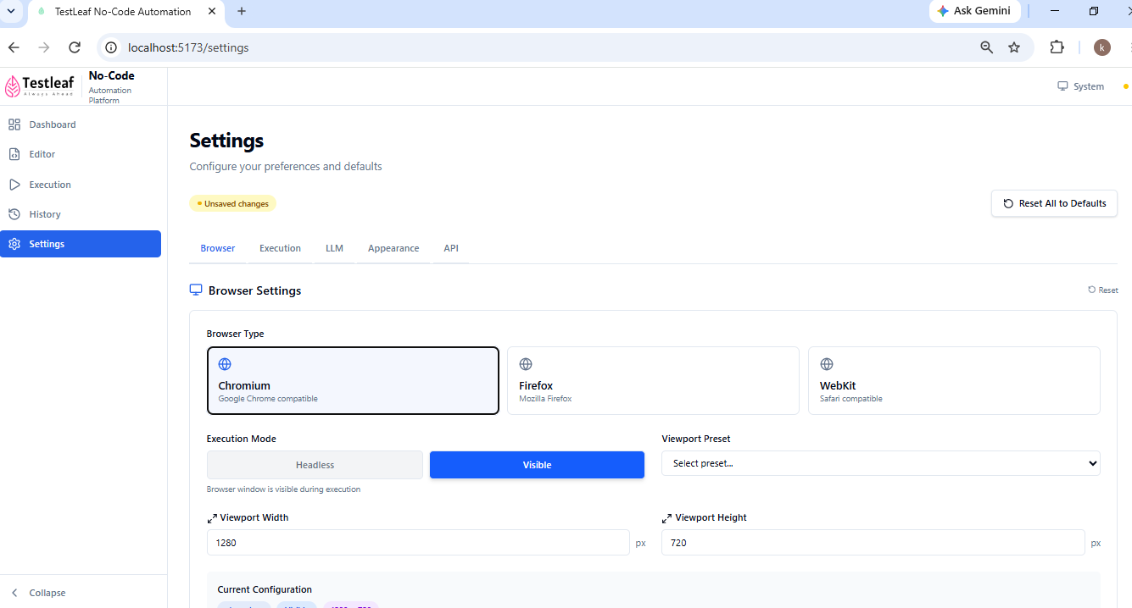
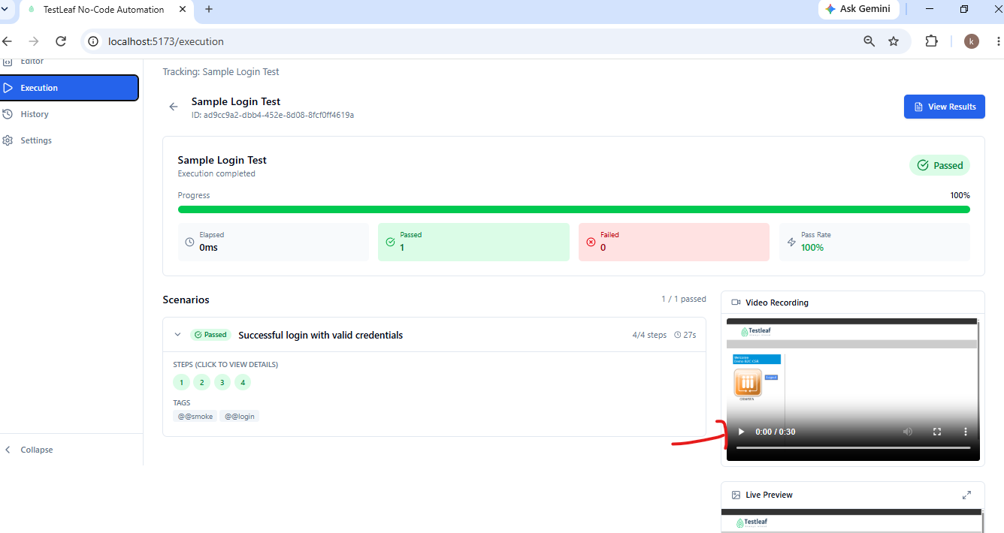
Execued headless / Head mode
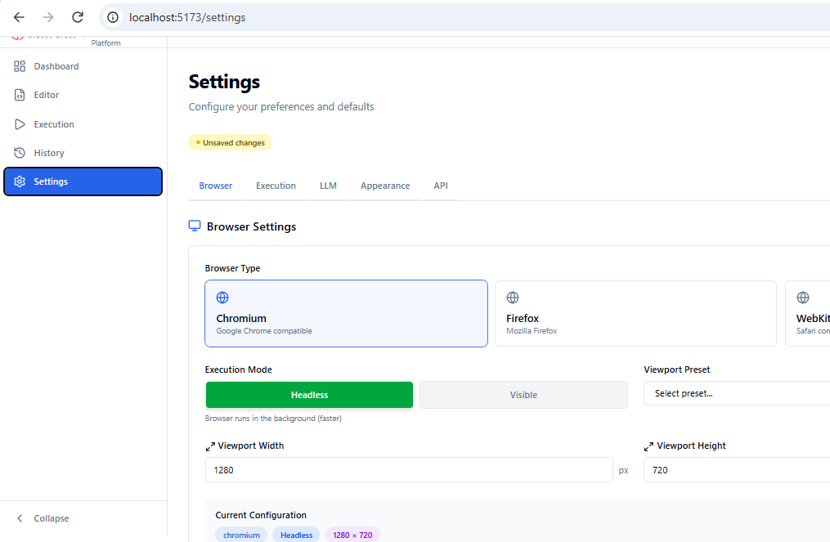
Retry Mechanism
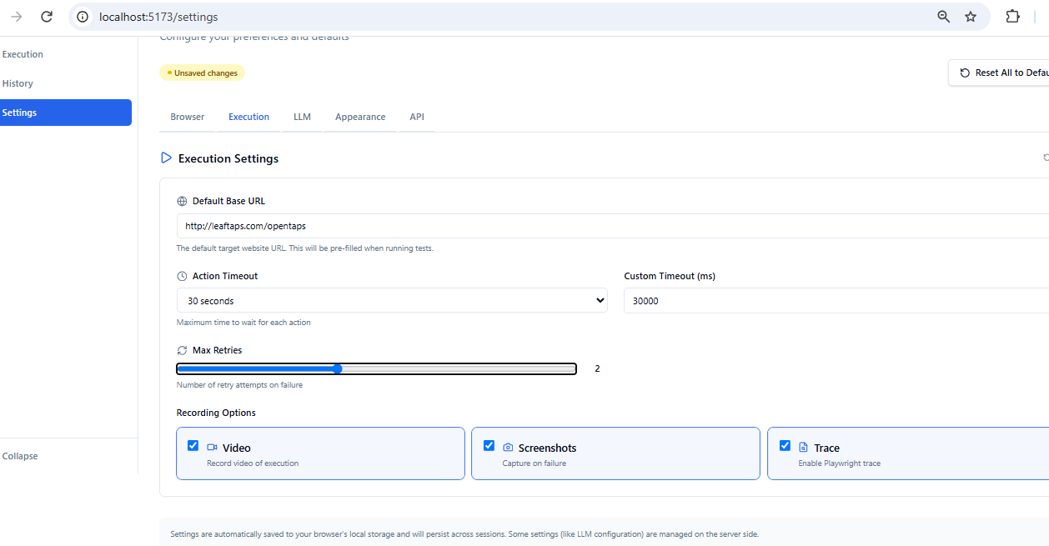
2. Implement LLM Configuration in Settings
Currently, the LLM configuration is maintained in the .env file.
Your task is to:
Move/implement the LLM configuration logic into the Settings tab.
A static UI for the LLM configuration is already available in the Settings tab.
Replace the existing static UI with the required functional implementation.
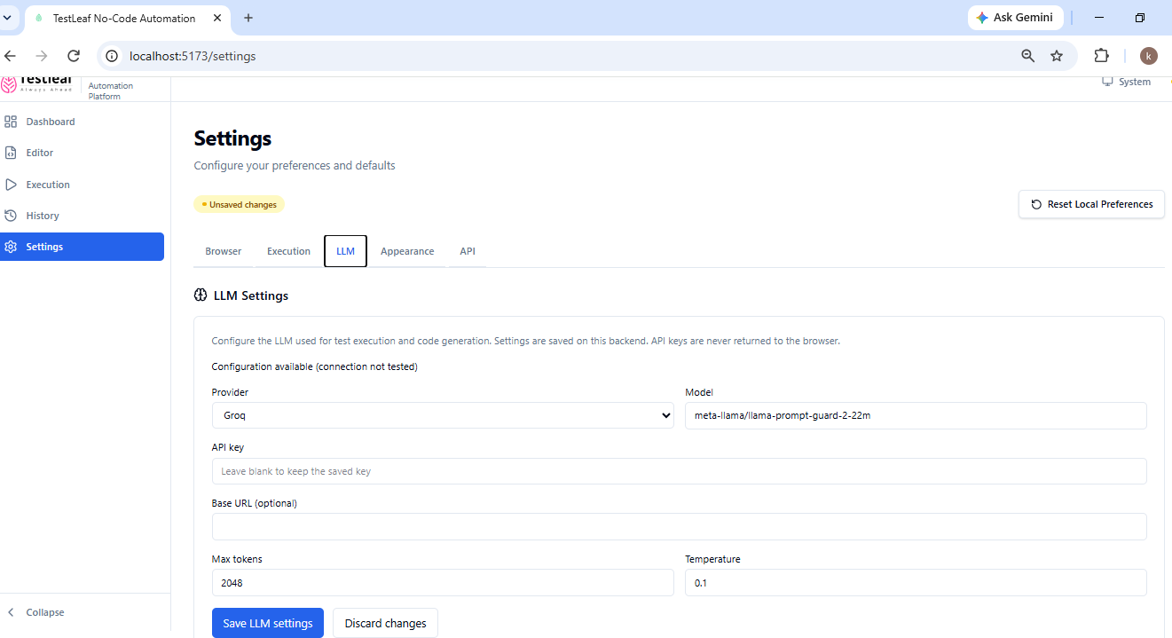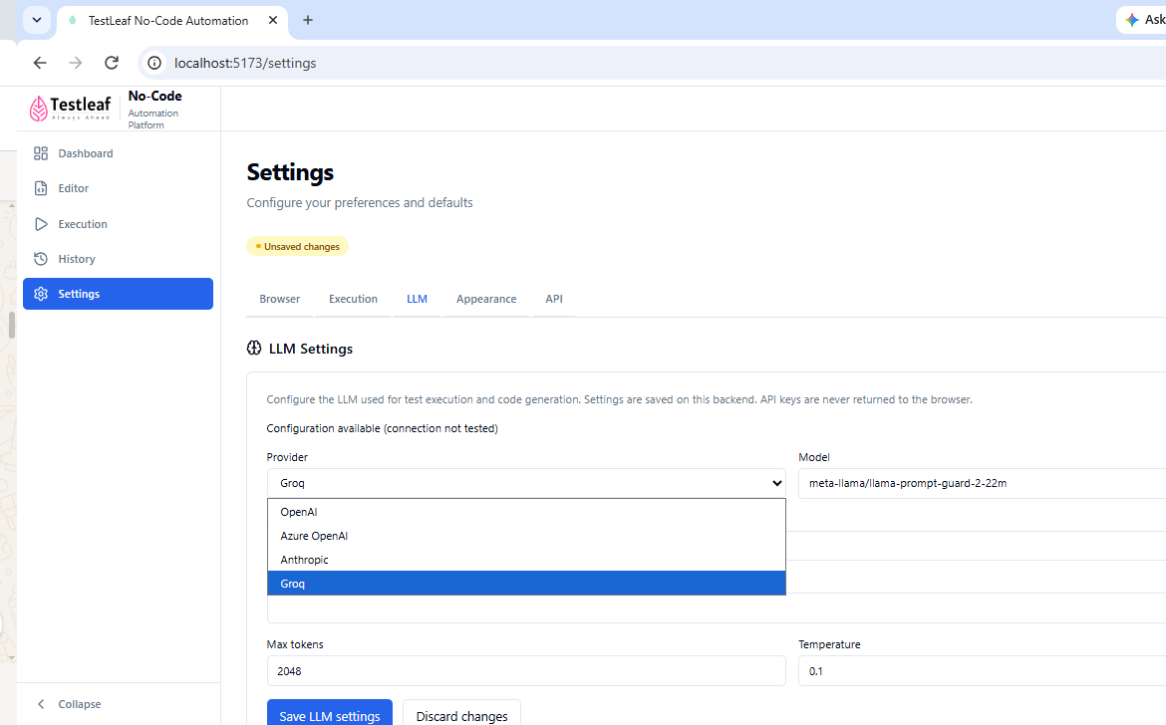
Plain English input
